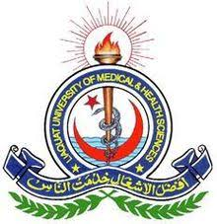
Office of Research Innovation & Commercialization
Medical Research Center
Research Trainings/Workshops
Full Name: ____________________________________________________________________
Institution: ____________________________________________________________________
Designation: ___________________________________________________________________
Qualifications: _________________________________________________________________
Email Address: _________________________________________________________________
Contact No.: ___________________________________________________________________

Please select the workshops for registration.
- 2-Days workshop on Synopsis Writing, Fee Rs. 2000/=
- 3-Days workshop on Research Methodology, Fee Rs. 3000/=
- 3-Days workshop on SPSS For Data Analysis, Fee Rs. 3000/=
- 2-Days workshop on Thesis Writing, Fee Rs. 2000/=
- 1- Day workshop on Manuscript Writing, Fee Rs. 1000/=
- 5-days workshop for Faculty, Fee Rs. 5000/=
- 3-Days workshop on ICH-GCP Certificate, Fee Rs. 5000/=
- 1-day workshop on Plagiarism, Fee Rs. 1000/=

Signature: ______________________________________________________________
Please attach the challan copy of bank draft with registration form.
Bank Details for Fee submission:
National Bank of Pakistan
Account Title: DIRECTOR ORIC
Account Number: 4135500891
IBAN: PK67NBP0131004135500891

For further details please visit: Medical Research Center, LUMHS Jamshoro

